As a reminder, here is the picture I was using, vs my result:
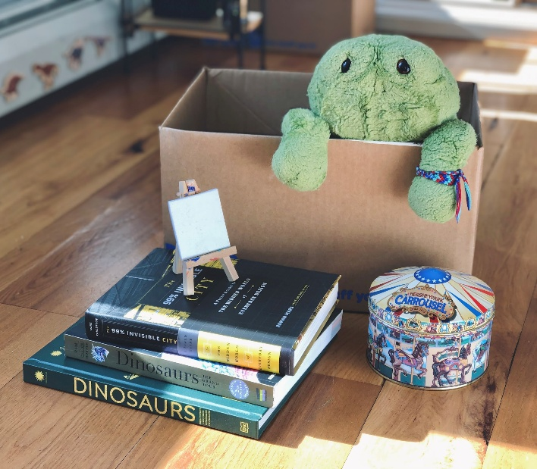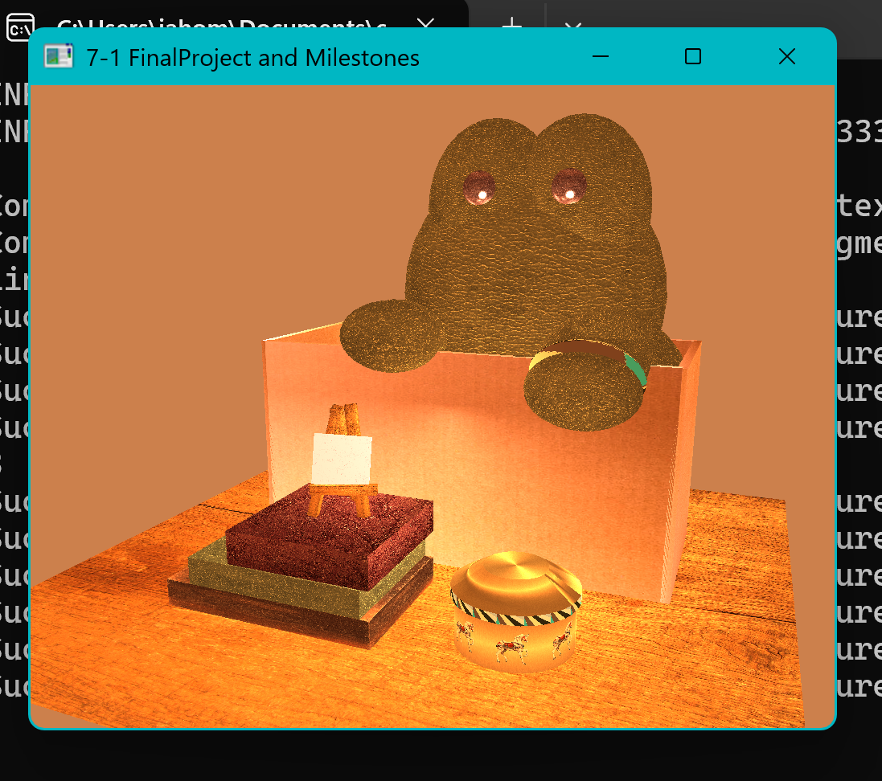
My reasoning for selecting these objects I had here is I felt they allowed me to slowly get more comfortable with sculpting my 3D scene. The various shapes meant that I would get used to using different meshes and build my skill in rotation and sizing. Seeing the pictures side by side now, I see areas I could have improved. The frog is too big, the box should be slightly longer, the metal tin should be farther right and bigger, and the books should be longer. However, I think I did fairly well, nonetheless.
For my 3D objects, it was required that I had at least one object comprised of multiple shapes (AKA a complex object) and I think the frog, the canvas, and the metal tin are all good examples of that. The frog is mostly made up of spheres rotated and elongated to match his natural soft shape, and a torus placed on his wrist to mimic his friendship bracelet. The canvas is again, mostly boxes elongated and rotated but I had some trouble setting the legs up to sit how they were meant to sit. The metal tin, however, is made using just 2 cylinders and 1 tapered cylinder. That was the object I chose to start with.
Any user who boots up my scene will be able to move left, right, backward, forwards, up, and down, and, with some slight effort, will be able to fully turn around in my 3D scene. My scene also has zoom functionality and can switch between orthographic and perspective views. This is all done via the mouse and keyboard on your computer. Setting up control functionality for the camera in my 3D scene was fairly simple, should you press any of the keys I set as controls (W, A, S, D, Q, E, P, O) the program will recognize that key as an input device and adjust the camera accordingly.
There are quite a few custom functions but the one I'll focus on is lighting. My lighting method is written out in a way that eliminates the need to create a custom light source every time I want to add a new light to the scene. Instead, I can write about 5 lines of code with whatever variations I like and have a new light present in my scene. This is a great reusable method because it's incredibly simple and cuts down a lot of the time I would usually spend on building a light.

